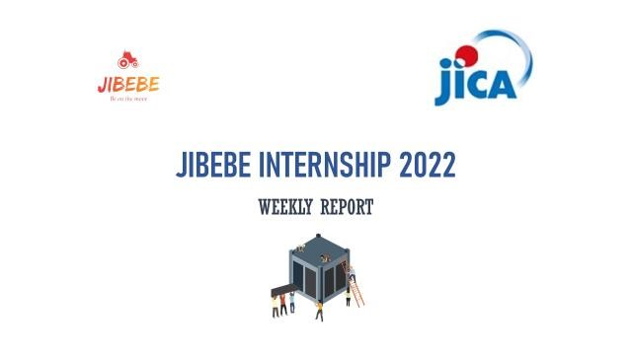

Internship 2022

Progress report

Name: ADHO MAMO

# Tasks completed last week

* [#74] Hydraulic Control Systems

The hydraulic control systems being used on farm tractors can be classified into three systems. Modifications and combinations of these systems exist. These systems include: Nudging system, Automatic Position-Control System, and automatic draft control system.

***Automatic Draft-Control System***

This is a type of restrained link system in which depth of implement is automatically adjusted to maintain a preselected constant draft. If soil resistance is uniform, depth fluctuations caused by irregular ground are less with automatic draft control than with automatic position control. In field, depth will vary as a result of variations in soil resistance, regardless of whether the field is smooth or undulating. In smooth fields, automatic draft control maintains average draft within the available power or tractive ability of tractor. When an overload condition occurs, automatic draft control system attempts to lift the implement against gravity and its inertia and against any downward soil force components. The lifting action behind the tractor results in a counter balancing lifting action of front wheels. Thus, momentarily vertical load from both implements and front wheels transfers to drive wheels and minimizes wheel slippage. If excessive soil resistance persists over any appreciable distance, implement depth is reduced. These systems will automatically raise or lower an implement-as-the draft or resistance of the attached implement increases or decreases. The sensing device, which tells the hydraulic system to lower or raise the hitch system, is located on either the lower links or the upper link depending on the size of the tractor. The position of the hand control lever, in effect, establishes the draft to be maintained. For example, a draft control system on a tractor pulling a plough will raise and lower the plough to maintain a constant force on the sensing device. A simple form of a draft-control system is shown in the figure

***Draft Sensing***

When the draft-control system was first developed by the late Harry Ferguson, the draft-sensing device was located on the upper link and responded to a compressive force. For a close-coupled implement—for example, a two-bottom plough, the upper link will normally be in compression, and as the draft increases, the compressive force will increase. The compressive force in the upper link becomes smaller as the size of an integrally mounted plow increases, and will often be a tension force for mounted ploughs of four or five bottoms and larger. Thus, it becomes more difficult to use the force on the upper link to sense the draft, or change in draft, of the plough. Lower link sensing is then preferred.

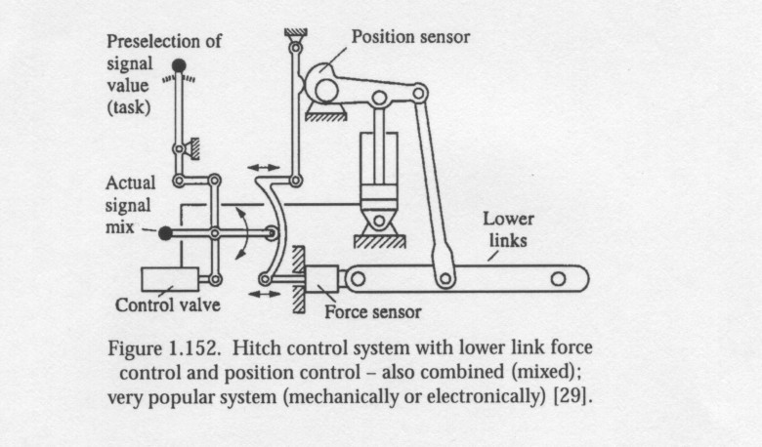

**Hitch control system with lower link force control and position control**

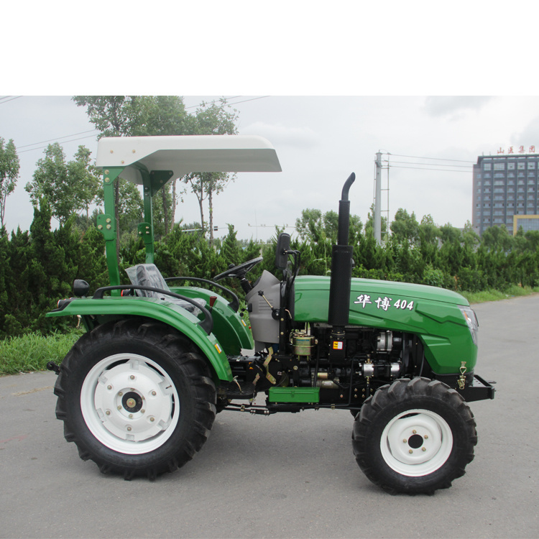

# Tasks in this week

● [#49] Computer vision (vehicle detection, static and dynamic objects )

# Timeline

|  |  |  |
| --- | --- | --- |
| Month | Intern week | Tasks |
| Jan |  |  |
| Week 1 | Identification of parts and drawing of the chassis diagram. |
| Week 2 | Circuit diagram and acquisition of parts. |
| Week 3 | Definition of the path to be followed by the robot car.  Laser cutting of the parts. |

|  |  |  |
| --- | --- | --- |
| Feb | Week 4 | * Assembly of the robot * Ultrasonic program implementation |
| Week 5 | * GPS and compass navigation * Path definition |
| Week 6 | Object identification using computer vision. (Raspberry pi & camera) |
| Week 7 | Transmission of live feed and data from the robot (transmitter and receiver) |
|  | Week 8 | Object dection (static and dynamic) |